Multinational Strategy

John Wensink

MGT350 - Business Policy and Strategy

Colorado State University-Global Campus

Dr. Jenn Dorwart

October 6, 2019

Multinational Strategy

When an organization decides to operate in multiple countries simultaneously, successful planners will determine which international strategy the company will use in order to gain the greatest competitive advantage for its products. Choosing the optimal strategy that will be most appropriate for a specific type of product is a trade-off between the benefits that centralization offers, versus the amount of local control that is required for the venture to be successful. Centralized operations have economies of scale in terms of manufacturing, distribution, and technical knowledge, however, the need to be able to respond to local preferences with agility will limit the degree of centralization that is possible. Consideration of local realities such as economic development, climate, and consumer preferences will determine the degree of local control that is needed for a firm to maintain agility in foreign markets. There exist three primary strategies that can be used to optimize this trade-off. The multi-domestic approach offers the least amount of benefit from centralization with a think-local act-local viewpoint that prioritizes federated production at the most local level. Having a multi-domestic approach gives companies the greatest amount of local control which can be required for products in areas with the highest degree of differentiation from the home market. On the other end of the spectrum is a globalized strategy where an organization seeks to offer a highly standardized product that can be produced and sold easily invariant of the geographical location. The globalized strategy seeks to think-globally and act globally by using highly centralized, unitary business activities in order to gain a competitive advantage. Standardizing operations across the globe makes scale economies more fesable, however, it has pronounced weaknesses when competing with more specialized firms indigenous to the region, and modifying its business plan is costlier and less practical. A hybrid of sorts exists as the transnational strategy where firms think-globally yet act-locally. Economies of scale here are balanced with strategies that can make the homogenized product more palatable to the region’s preferences. One example of a transnational strategy would be to offer the company’s product in single-serving quantities in areas with less economic development so that individuals can purchase only what is immediately necessary at the time it is needed. Let’s discuss a few examples of how different types of products can benefit from the three different approaches.

**Soup**

Soups and most other foods would benefit the most from having a multi-domestic strategy “where meeting local taste sensibilities is of critical importance, [one] cannot disregard the issue of local responsiveness in regard to their end products.”(Gooderham, 2012, p.6) With prepackaged soups, a globalized or transnational strategy would not be appropriate as it is highly likely that a region’s consumers would prefer spices and flavors unique to the region’s cultural heritage. Applying a multi-domestic approach to pre-packaged food would allow a company to market their product using specialized branding and packaging that is relevant to the region in question. Economies of scale here would give way to the localized supply of food ingredients that can be produced and procured in the region with potential for efficiencies in production and transportation of the raw materials used in making the firm’s product.

**Washing Machines**

A company whose product includes washing machines, as with other household appliances would be best served by utilizing a transnational strategy. A company with good brand recognition would have a competitive advantage in recognizability, yet would find its products useless in markets with differing electrical and plumbing infrastructure without some degree of specialization based on the geographic area of its intended use. Aesthetic considerations are also important to keep in mind, as well as how often such machines are intended to be used. The figures below depict how the variation of temperature, as well as the preference of fabric softeners of a washing machine is highly dependant on the country in which it is used.

.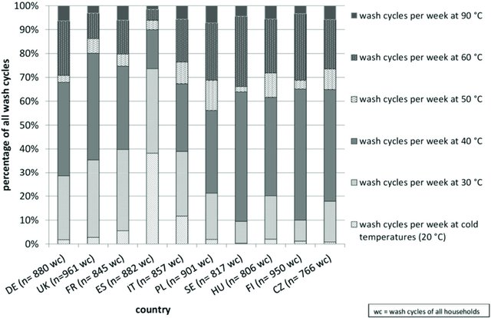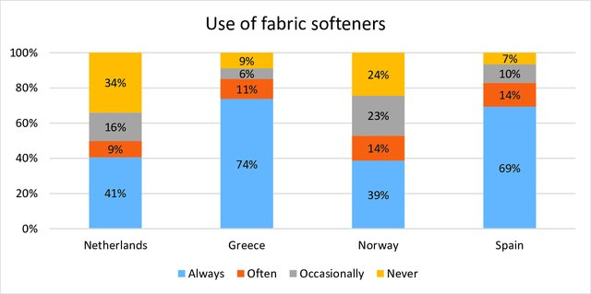

(Laitala, Klepp, & Henry, 2017)

It would not make sense to use a multi-domestic strategy in the case of home appliances, as there are many economies of scale which can offer substantial benefit in the manufacturing of durable goods such as washing machines, rather, only small modifications would be necessary to make the products marketable to different regions of the world.

**Mobile Phones**

A mobile phone is an electronic device that would deliver maximum benefit to its manufacturer by applying standardization and integrating the product in all areas of its distribution. The hardware for a mobile phone would require little to no modification to make it suitable for sale in every part of the world. The phone’s operating system and apps could be adapted to individual regions without having to de-centralize its production. The maximum benefit for a mobile phone manufacturer could be achieved by finding the region that can produce the phones at the lowest cost, and having a unitary production strategy that takes advantage of economies of scale. The Apple Computer Corporation is a leader in the sales of mobile hardware. It has worldwide brand recognition. Apple does not differentiate its products based on geographic location “choosing not to adapt its products to the local culture, because it does not need to. Apple is the culture.” (Hovivian, 2018) There is little to no benefit to breaking up the production of mobile phones, and centralization can be leveraged to its maximum degree

**International Strategy**

Choosing an international strategy could mean the difference between success and failure of a multinational venture. There are countless ways in which an international presence can improve a company’s bottom line. It is important to take into consideration which approach suits a particular product to maximize economies of production, distribution, and marketing. The key is to understand how much local control is needed for a product to be successful and federate its strategy only to the extent necessary for the venture to be successful.

References

Gooderham, P. (2012). The transition from a multi-domestic to globally integrated multinational enterprise in an industry where local taste matters. *European J. of International Management*, *6*(2), 175. Retrieved from <http://citeseerx.ist.psu.edu/viewdoc/download?doi=10.1.1.458.1169&rep=rep1&type=pdf>

Hovivian, F. (2018, February 28). Globalization: Apple's One-Size-Fits-All Approach. Retrieved October 6, 2019, from <http://www.brandquarterly.com/globalization-apples-one-size-fits-approach>.

Laitala, K., Klepp, I., & Henry, B. (2017). Use Phase of Apparel: A Literature Review for Life Cycle Assessment with Focus on Wool. *Consumption Research Norway*, *6*. Retrieved from <https://www.researchgate.net/publication/323551373_Use_phase_of_apparel_A_literature_review_for_Life_Cycle_Assessment_with_focus_on_wool/figures?lo=1>